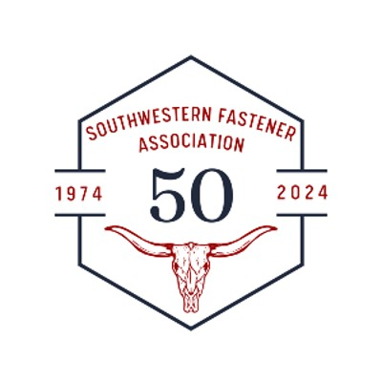
50/50 RAFFLE
$20 per chance
6 for $100
Cash or Venmo
Drawing held at
Joe T Garcia’s dinner

